SIMATS ENGINEERING
ASSESSMENT TOOL 2

COURSE CODE:ITA0604 COURSE NAME: MACHINE LEARNING COURSE OUTCOME COVERED
CO2: Neural Network Representation, Perceptron Model, Multilayer Perceptrons,
Backpropagation Algorithm, Deep Neural Networks, Genetic Algorithms, Hypothesis
Space Search, Genetic Programming, Models of Evaluation and Learning (BL1, BL2) Assessment Tool Weightage: 20%

QUESTIONS: 15 Total Marks:100
Annexure A
SCENARIO-BASED QUESTIONS
Code of Conduct:
I ___P.Sree Vaishnavi(192412219)_________________ (Name / Reg No) certify that this submission is my original work and that I have adhered to the guidelines specified for this assessment.
Criteria | Conceptual  Understanding | Accuracy of  Answers | Application of  Knowledge | Completeness of Response | Clarity &  Presentation | Total
Weightage | 30% | 20% | 20% | 15% | 15%
Q1
Q2
Q3
I understand that any violation of academic integrity rules will result in disciplinary action.
Signature of the student:
Total
Marks
Awarded
Annexure A
Short Answer Test
- With the help of a neat diagram, explain the architecture of a decision tree learning system. Describe how features are selected using measures such as entropy and information gain. Illustrate the process of tree construction and pruning using a small example dataset, and explain how overfitting can be controlled in decision tree
models. (5 Marks)
- Design a machine learning system for smart traffic management to predict traffic congestion using data such as vehicle density, time of day, weather conditions, and road type. Justify the choice of algorithm, explain preprocessing and feature engineering steps, and describe how the model can be trained, validated, and
deployed for real-time decision-making. (5 Marks)
- In the context of Convolutional Neural Networks (CNNs), explain the different layers involved, including convolutional, pooling, and fully connected layers. Describe how feature maps are generated and how backpropagation updates weights in CNNs. Illustrate the process with an example of image classification and discuss
factors affecting model performance. (5 Marks)

RUBRICS FOR CALCULATION
Criteria | Weightage | Level 4 –  Exemplary (5  Marks) | Level 3 –  Proficient (4  Marks) | Level 2 –  Developing (2–3 Marks) | Level 1 –  Beginning (0–1  Mark)
Conceptual  Understanding | 30 | Demonstrates clear and complete understanding of  the concept | Good  understanding  with minor gaps | Basic understanding with some  misconceptions | Poor or incorrect  understanding
Accuracy of  Answer | 20 | Completely correct answer with no  errors | Mostly correct with minor errors | Partially correct with noticeable errors | Incorrect or  irrelevant answer
Application of  Knowledge | 20 | Correctly applies concepts to solve  the  question/problem | Applies concepts  with minor  mistakes | Limited or partially  correct application | No or incorrect application
Completeness of Response | 15 | Covers all required parts of the  question | Covers most parts with minor  omissions | Covers only some  parts | Incomplete or missing response
Clarity &  Presentation | 15 | Clear, concise, and well-organized answer | Understandable  with minor  issues | Somewhat unclear  or poorly structured | Difficult to understand

6. Decision Tree Learning System
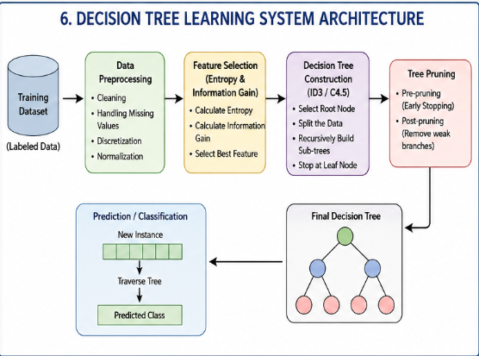
Feature Selection
Decision trees select the best feature using Entropy and Information Gain.
Entropy:
$$Entropy\left(S\right)=-\sum{p_{i}}\log_{2}p_{i}$$
Measures the impurity of the dataset.
Information Gain:
$$Gain\left(S , A\right)=Entropy\left(S\right)-\sum{\frac{∣S_{v}∣}{∣S∣}}Entropy\left(S_{v}\right)$$
The feature with the highest information gain becomes the root node.
Controlling Overfitting
- Pre-pruning (maximum depth)
- Minimum samples per leaf
- Minimum information gain
- Post-pruning
- Cross-validation

7. Machine Learning System for Smart Traffic Management

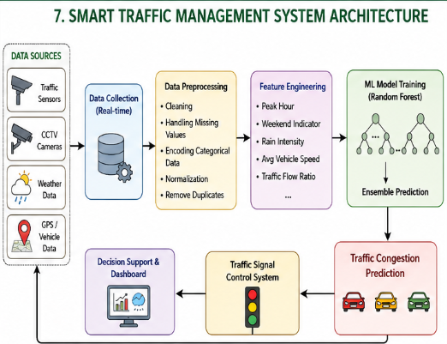

Input Features
- Vehicle density
- Time of day
- Weather condition
- Road type
- Traffic speed
- Day of week

Algorithm Choice
Random Forest
Reason:
- High accuracy
- Handles nonlinear data
- Robust to noise
- Less overfitting
- Fast prediction

Preprocessing
- Remove missing values
- Encode categorical data
- Normalize numerical features
- Remove duplicate records

Feature Engineering
Create new features:
- Peak hour
- Weekend indicator
- Rain intensity
- Average vehicle speed
- Traffic flow ratio

Training
- Split dataset (80% Train, 20% Test)
- Train Random Forest model

Validation
Evaluate using:
- Accuracy
- Precision
- Recall
- F1-score
- Confusion Matrix

Deployment
- Deploy on cloud/server
- Receive live sensor data
- Predict congestion
- Automatically adjust traffic signals
- Display alerts on monitoring dashboard

8. Convolutional Neural Network (CNN)
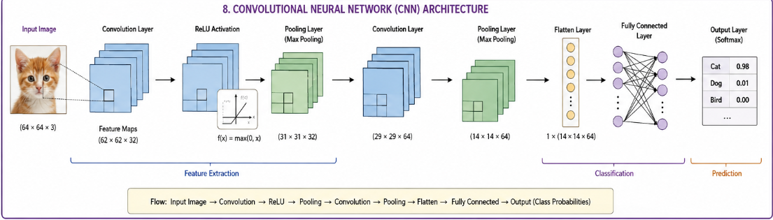
Layers in CNN
1. Convolution Layer
- Applies filters (kernels)
- Extracts edges, textures, shapes
- Produces feature maps

2. ReLU Layer
$$ReLU\left(x\right)=max⁡\left(0 , x\right)$$
Introduces non-linearity.

3. Pooling Layer
Reduces feature map size.
Types:
- Max Pooling
- Average Pooling
Benefits:
- Reduces computation
- Prevents overfitting

4. Fully Connected Layer
- Combines extracted features
- Produces final class probabilities
Backpropagation
Steps:
- Forward pass
- Calculate loss
- Compute gradients
- Update weights using Gradient Descent
- Repeat until loss decreases
Weight Update:
$$W_{new}=W_{old}-η\frac{∂Loss}{∂W}$$
where η is the learning rate.
Factors Affecting CNN Performance
- Dataset quality
- Number of convolution layers
- Filter size
- Learning rate
- Batch size
- Number of epochs
- Pooling method
- Data augmentation
- Regularization (Dropout)
- Hardware (GPU)

